Joseph Sansevero

9/12/2019

Provisional Patent

Elevator Contract Management Tool

# Field of the Invention

The present invention relates to the Elevator Consulting industry. In particular, the invention utilizes modern open-source technologies to build an application to aid in the monitoring of a client receiving the agreed upon services from the given contractor.

# Background of the Invention

This invention relates to the elevator consulting industry by targeting a need to be able to accurately self-report the extent to which a contract signed with an Elevator manufacturer is being upheld. The application has two main features; a data entry form, and a dashboard. The data entry form allows an employee of a given client to collect data on the fulfillment of their contract. The Dashboard feature then aggregates this information to quickly display the key statistics based on their given contract.

In elevator consulting there are two common features that an elevator contractor is required to uphold; Preventative Maintenance, and Emergency Call Back. Preventative maintenance is the portion of the contract that discusses how regularly the contractor will make maintenance visits to the client site. If the contractor is not meeting this standard there is often a financial penalty associated with this. Similarly, the Emergency Call Back section also has a financial penalty, but this is related to the response time from the given phone call. This application will aggregate this information for the client to quickly determine if they’re entitled to any penalties as a result of a failure for the contractor to meet the predetermined terms.

# Description of the Invention

When an elevator contractor arrives at the site the client or contractor will be asked to login to the website, this will then start them down a business logic path to the data entry screens. The first decision will be whether or not the data being entered is for Preventative Maintenance or Emergency Call Back. Based on this decision the user will be brought to the appropriate screen and asked to fill-out the relevant information. If the individual logging in has admin level permissions, then the individual will be taken directly to the dashboard that displays the relevant information for that particular client.

The application uses R an open source coding language. R is a programming language where individual developers build their own functions into series of functions called ‘libraries’. To build the application the Shiny library was used as well as some other commonly used libraries. The application is hosted on Amazon Web Services, as well as the relational database that supports the application. The Application is then accessed through a URL.

Following are the various screens that have been created as described in the prior paragraphs. The initial screen is the login where they will be brought to either the second image “Type of data entry” or the Dashboard depending on their level of access. From there the logic will follow based on whichever type of data needs to be entered.

# Images

### Image 1 – Login Screen

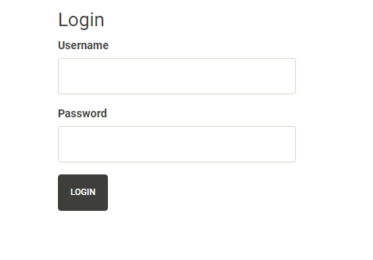

### Image 2 – Type of Data Entry

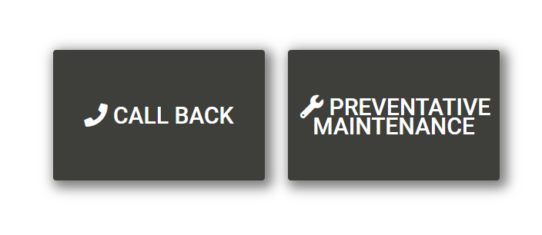

### Image 3 – Preventative Maintenance

### C:\Users\Joseph\Pictures\CE App\PM.PNG

### Image 4 – Call Back Part 1

### C:\Users\Joseph\Pictures\CE App\Callback_1.PNGImage 4 – Call Back Stage 1

### Image 5 – Call Back Stage 2

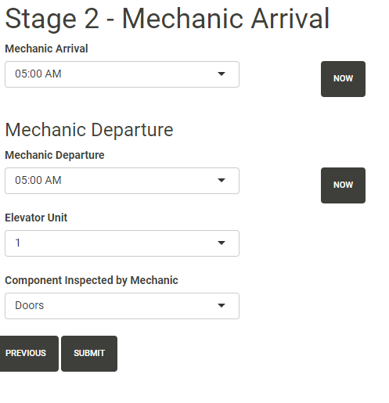

### C:\Users\Joseph\Pictures\CE App\Dashboard.PNGImage 6 –Dashboard